# Question

Write an algorithm to determine if a number n is happy.

A **happy number** is a number defined by the following process:

* Starting with any positive integer, replace the number by the sum of the squares of its digits.
* Repeat the process until the number equals 1 (where it will stay), or it **loops endlessly in a cycle** which does not include 1.
* Those numbers for which this process **ends in 1** are happy.

Return true *if* n *is a happy number, and* false *if not*.

**Example 1:**

**Input:** n = 19

**Output:** true

**Explanation:**

12 + 92 = 82

82 + 22 = 68

62 + 82 = 100

12 + 02 + 02 = 1

**Example 2:**

**Input:** n = 2

**Output:** false

**Constraints:**

* 1 <= n <= 231 - 1

# Solution

## **Solution**

#### **Approach 1: Detect Cycles with a HashSet**

**Intuition**

A good way to get started with a question like this is to make a couple of examples. Let's start with the number 77. The next number will be 4949 (as 7^2 = 4972=49), and then the next after that will be 9797 (as 4^2 + 9^2 = 9742+92=97). We can continually repeat the process of squaring and then adding the digits until we get to 11. Because we got to 11, we know that 77 is a happy number, and the function should return true.

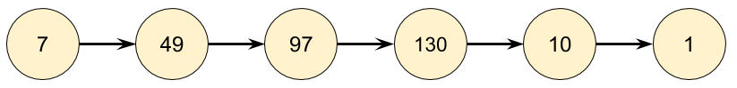

As another example, let's start with 116116. By repeatedly applying the squaring and adding process, we eventually get to 5858, and then a bit after that, we get back to 5858. Because we are back at a number we've already seen, we know there is a cycle, and therefore it is impossible to ever reach 11. So for 116116, the function should return false.

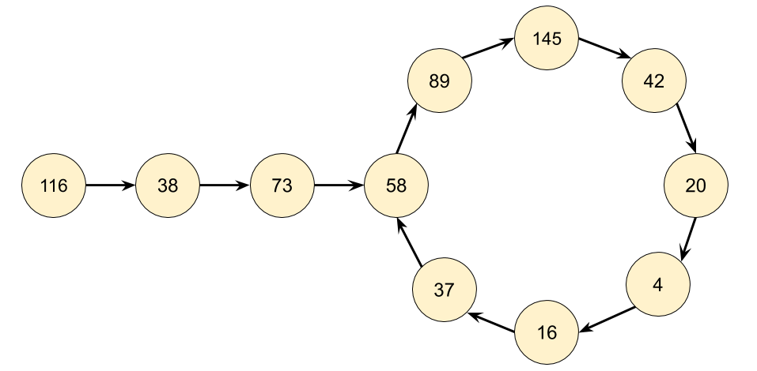

Based on our exploration so far, we'd expect continually following links to end in one of three ways.

1. It eventually gets to 11.
2. It eventually gets stuck in a cycle.
3. It keeps going higher and higher, up towards infinity.

That 3rd option sounds really annoying to detect and handle. How would we even know that it is going to continue going up, rather than eventually going back down, possibly to 1?1? Luckily, it turns out we don't need to worry about it. Think carefully about what the largest next number we could get for each number of digits is.

| **Digits** | **Largest** | **Next** |
| --- | --- | --- |
| 1 | 9 | 81 |
| 2 | 99 | 162 |
| 3 | 999 | 243 |
| 4 | 9999 | 324 |
| 13 | 9999999999999 | 1053 |

For a number with 33 digits, it's impossible for it to ever go larger than 243243. This means it will have to either get stuck in a cycle below 243243 or go down to 11. Numbers with 44 or more digits will always lose a digit at each step until they are down to 33 digits. So we know that at worst, the algorithm might cycle around all the numbers under 243243 and then go back to one it's already been to (a cycle) or go to 11. But it won't go on indefinitely, allowing us to rule out the 3rd option.

Even though you don't need to handle the 3rd case in the code, you still need to understand why it can never happen, so that you can justify why you didn't handle it.

**Algorithm**

There are 2 parts to the algorithm we'll need to design and code.

1. Given a number n*n*, what is its next number?
2. Follow a chain of numbers and detect if we've entered a cycle.

Part 1 can be done by using the division and modulus operators to repeatedly take digits off the number until none remain, and then squaring each removed digit and adding them together. Have a careful look at the code for this, "picking digits off one-by-one" is a useful technique you'll use for solving a lot of different problems.

Part 2 can be done using a **HashSet**. Each time we generate the next number in the chain, we check if it's already in our HashSet.

* If it is not in the HashSet, we should add it.
* If it is in the HashSet, that means we're in a cycle and so should return false.

The reason we use a **HashSet** and not a Vector, List, or Array is because we're repeatedly checking whether or not numbers are in it. Checking if a number is in a HashSet takes O(1)*O*(1) time, whereas for the other data structures it takes O(n)*O*(*n*) time. Choosing the correct data structures is an essential part of solving these problems.

|  |
| --- |
| class Solution {  private int getNext(int n) {  int totalSum = 0;  while (n > 0) {  int d = n % 10;  n = n / 10;  totalSum += d * d;  }  return totalSum;  }  public boolean isHappy(int n) {  Set<Integer> seen = new HashSet<>();  while (n != 1 && !seen.contains(n)) {  seen.add(n);  n = getNext(n);  }  return n == 1;  }  } |

|  |
| --- |
| def isHappy(self, n: int) -> bool:  def get_next(n):  total_sum = 0  while n > 0:  n, digit = divmod(n, 10)  total_sum += digit ** 2  return total_sum  seen = set()  while n != 1 and n not in seen:  seen.add(n)  n = get_next(n)  return n == 1 |

**Complexity Analysis**

Determining the time complexity for this problem is challenging for an "easy" level question. If you're new to these problems, have a go at calculating the time complexity for just the getNext(n) function (don't worry about how many numbers will be in the chain).

* Time complexity : O(243 \cdot 3 + \log n + \log\log n + \log\log\log n)...*O*(243⋅3+log*n*+loglog*n*+logloglog*n*)... = O(\log n)*O*(log*n*).

Finding the **next** value for a given number has a cost of O(\log n)*O*(log*n*) because we are processing each digit in the number, and the number of digits in a number is given by \log nlog*n*.

To work out the total time complexity, we'll need to think carefully about how many numbers are in the chain, and how big they are.

We determined above that once a number is below 243243, it is impossible for it to go back up above 243243. Therefore, based on our very shallow analysis we know for sure that once a number is below 243243, it is impossible for it to take more than another 243243 steps to terminate. Each of these numbers has at most 3 digits. With a little more analysis, we could replace the 243243 with the length of the longest number chain below 243243, however because the constant doesn't matter anyway, we won't worry about it.

For an n*n* above 243243, we need to consider the cost of each number in the chain that is above 243243. With a little math, we can show that in the worst case, these costs will be O(\log n) + O(\log \log n) + O(\log \log \log n)...*O*(log*n*)+*O*(loglog*n*)+*O*(logloglog*n*).... Luckily for us, the O(\log n)*O*(log*n*) is the dominating part, and the others are all tiny in comparison (collectively, they add up to less than \log n)log*n*), so we can ignore them.

* Space complexity : O(\log n)*O*(log*n*). Closely related to the time complexity, and is a measure of what numbers we're putting in the HashSet, and how big they are. For a large enough n*n*, the most space will be taken by n*n* itself.

We can optimize to O(243 \cdot 3) = O(1)*O*(243⋅3)=*O*(1) easily by only saving numbers in the set that are less than 243243, as we have already shown that for numbers that are higher, it's impossible to get back to them anyway.

It might seem worrying that we're simply dropping such "large" constants. But this is what we do in Big O notation, which is a measure of how long the function will take, as the size of the input increases.

Think about what would happen if you had a number with 1 million digits in it. The first step of the algorithm would process those million digits, and then the next value would be, at most (pretend all the digits are 9), be 81 * 1,000,000 = 81,000,00081∗1,000,000=81,000,000. In just one step, we've gone from a million digits, down to just 8. The largest possible 8 digit number we could get is 99,9999,99999,9999,999, which then goes down to 81 * 8 = 64881∗8=648. And then from here, the cost will be the same as if we'd started with a 3 digit number. Starting with 2 million digits (a **massively** larger number than one with a 1 million digits) would only take roughly twice as long, as again, the dominant part is summing the squares of the 2 million digits, and the rest is tiny in comparison.

#### **Approach 2: Floyd's Cycle-Finding Algorithm**

**Intuition**

The chain we get by repeatedly calling getNext(n) is an implicit **LinkedList**. Implicit means we don't have actual LinkedNode's and pointers, but the data does still form a LinkedList structure. The starting number is the head "node" of the list, and all the other numbers in the chain are nodes. The next pointer is obtained with our getNext(n) function above.

Recognizing that we actually have a LinkedList, it turns out that this question is almost the same as another Leetcode problem, [detecting if a linked list has a cycle](https://leetcode.com/problems/linked-list-cycle). As @Freezen [has pointed out](https://leetcode.com/problems/happy-number/discuss/56917/My-solution-in-C(-O(1)-space-and-no-magic-math-property-involved-)), we can therefore use Floyd's Cycle-Finding Algorithm here. This algorithm is based on 2 runners running around a circular race track, a fast runner and a slow runner. In reference to a famous fable, many people call the slow runner the "tortoise" and the fast runner the "hare".

Regardless of where the tortoise and hare start in the cycle, they are guaranteed to eventually meet. This is because the hare moves one node closer to the tortoise (in their direction of movement) each step.

**Algorithm**

Instead of keeping track of just one value in the chain, we keep track of 2, called the slow runner and the fast runner. At each step of the algorithm, the slow runner goes forward by 1 number in the chain, and the fast runner goes forward by 2 numbers (nested calls to the getNext(n) function).

If n *is* a happy number, i.e. there is no cycle, then the fast runner will eventually get to 1 before the slow runner.

If n *is not* a happy number, then eventually the fast runner and the slow runner will be on the same number.

|  |
| --- |
| class Solution {  public int getNext(int n) {  int totalSum = 0;  while (n > 0) {  int d = n % 10;  n = n / 10;  totalSum += d * d;  }  return totalSum;  }  public boolean isHappy(int n) {  int slowRunner = n;  int fastRunner = getNext(n);  while (fastRunner != 1 && slowRunner != fastRunner) {  slowRunner = getNext(slowRunner);  fastRunner = getNext(getNext(fastRunner));  }  return fastRunner == 1;  }  } |

|  |
| --- |
| def isHappy(self, n: int) -> bool:  def get_next(number):  total_sum = 0  while number > 0:  number, digit = divmod(number, 10)  total_sum += digit ** 2  return total_sum  slow_runner = n  fast_runner = get_next(n)  while fast_runner != 1 and slow_runner != fast_runner:  slow_runner = get_next(slow_runner)  fast_runner = get_next(get_next(fast_runner))  return fast_runner == 1 |

**Complexity Analysis**

* Time complexity : O(\log n)*O*(log*n*). Builds on the analysis for the previous approach, except this time we need to analyse how much extra work is done by keeping track of two places instead of one, and how many times they'll need to go around the cycle before meeting.

If there is no cycle, then the fast runner will get to 1, and the slow runner will get halfway to 1. Because there were 2 runners instead of 1, we know that at worst, the cost was O(2 \cdot \log n) = O(\log n)*O*(2⋅log*n*)=*O*(log*n*).

Like above, we're treating the length of the chain to the cycle as insignificant compared to the cost of calculating the next value for the first n. Therefore, the only thing we need to do is show that the number of times the runners go back over previously seen numbers in the chain is constant.

Once both pointers are in the cycle (which will take constant time to happen) the fast runner will get one step closer to the slow runner at each cycle. Once the fast runner is one step behind the slow runner, they'll meet on the next step. Imagine there are k*k* numbers in the cycle. If they started at k - 1*k*−1 places apart (which is the furthest apart they can start), then it will take k - 1*k*−1 steps for the fast runner to reach the slow runner, which again is constant for our purposes. Therefore, the dominating operation is still calculating the next value for the starting n, which is O(\log n)*O*(log*n*).

* Space complexity : O(1)*O*(1). For this approach, we don't need a HashSet to detect the cycles. The pointers require constant extra space.

#### **Approach 3: Hardcoding the Only Cycle (Advanced)**

**Intuition**

The previous two approaches are the ones you'd be expected to come up with in an interview. This third approach is ***not something you'd write in an interview***, but is aimed at the mathematically curious among you as it's quite interesting.

What's the biggest number that could have a next value bigger than itself? Well we know it has to be less than 243243, from the analysis we did previously. Therefore, we know that any cycles must contain numbers smaller than 243243, as anything bigger could not be cycled back to. With such small numbers, it's not difficult to write a brute force program that finds all the cycles.

If you do this, you'll find there's only one cycle: 4 \rightarrow 16 \rightarrow 37 \rightarrow 58 \rightarrow 89 \rightarrow 145 \rightarrow 42 \rightarrow 20 \rightarrow 44→16→37→58→89→145→42→20→4. All other numbers are on chains that lead into this cycle, or on chains that lead into 11.

Therefore, we can just hardcode a HashSet containing these numbers, and if we ever reach one of them, then we know we're in the cycle. There's no need to keep track of where we've been previously.

|  |
| --- |
| class Solution {  private static Set<Integer> cycleMembers =  new HashSet<>(Arrays.asList(4, 16, 37, 58, 89, 145, 42, 20));  public int getNext(int n) {  int totalSum = 0;  while (n > 0) {  int d = n % 10;  n = n / 10;  totalSum += d * d;  }  return totalSum;  }  public boolean isHappy(int n) {  while (n != 1 && !cycleMembers.contains(n)) {  n = getNext(n);  }  return n == 1;  }  } |

|  |
| --- |
| def isHappy(self, n: int) -> bool:  cycle_members = {4, 16, 37, 58, 89, 145, 42, 20}  def get_next(number):  total_sum = 0  while number > 0:  number, digit = divmod(number, 10)  total_sum += digit ** 2  return total_sum  while n != 1 and n not in cycle_members:  n = get_next(n)  return n == 1 |

**Complexity Analysis**

Time complexity : O(\log n)*O*(log*n*). Same as above.

Space complexity : O(1)*O*(1). We are not maintaining any history of numbers we've seen. The hardcoded HashSet is of a constant size.

**An Alternative Implementation**

Thanks [@Manky](https://leetcode.com/manky/) for sharing this alternative with us!

This approach was based on the idea that all numbers either end at 1 or enter the cycle {4, 16, 37, 58, 89, 145, 42, 20}, wrapping around it infinitely.

An alternative approach would be to recognise that all numbers will either end at 1, or go past 4 (a member of the cycle) at some point. Therefore, instead of hardcoding the entire cycle, we can just hardcode the 4.

|  |
| --- |
| class Solution {    public int getNext(int n) {  int totalSum = 0;  while (n > 0) {  int d = n % 10;  n = n / 10;  totalSum += d * d;  }  return totalSum;  }    public boolean isHappy(int n) {  while (n != 1 && n != 4) {  n = getNext(n);  }  return n == 1;  }  } |

|  |
| --- |
| class Solution:    def isHappy(self, n: int) -> bool:    def get_next(number):  total_sum = 0  while number > 0:  number, digit = divmod(number, 10)  total_sum += digit ** 2  return total_sum    while n != 1 and n != 4:  n = get_next(n)    return n == 1 |

This alternative has the same time and space complexity as approach 3, from a big-oh point of view. The time taken in practice for this alternative will be slower by a constant amount though. If the cycle was entered at 16, then the algorithm will traverse the entire cycle before getting back to 4. The space complexity will be less by a constant amount, because we're now only hardcoding 4 and not the other 7 numbers in the cycle.